

CNN Model Project Report

  - Semester Project

Course:
Artificial Intelligence

Course Instructor:
Miss Abeeda Akram

Group Members:
Umer Karamat 23L-0873 (BCS-6K)
M Basim Irfan 23L-0846 (BCS-6K)
Umer Mujahid 23L-0774 (BCS-6K)
Muhammad Rehan 23L-0925 (BCS-6K)

National University Of Computer and Emerging Sciences
Department of Computer Science
Lahore, Pakistan
CNN-Based Lung Cancer Classification

1. Introduction
Lung cancer is one of the deadliest cancers worldwide, killing around 1.8 million people every year. The main reason for such a high death toll is late detection — by the time symptoms show, the cancer is often at an advanced stage. CT scans are commonly used to look for lung abnormalities but reading them accurately takes years of radiological training. Automating this with deep learning can speed up diagnosis and make it more consistent.
Non-Small Cell Lung Cancer (NSCLC) makes up about 85% of all lung cancer cases and has three main subtypes: Adenocarcinoma (AC), Squamous Cell Carcinoma (SCC), and Large Cell Carcinoma (LCC). Each subtype responds differently to treatment, so correctly identifying which one a patient has is clinically important.
In this project, we trained two CNN models to classify CT scan images into four categories: the three NSCLC subtypes and normal lung tissue. The first model was built from scratch (MiniConvNet), and the second used a pretrained MobileNetV2 with transfer learning.

2. Literature Review
The research paper selected for this project is titled:
“A lightweight CNN for enhanced non-small cell lung cancer classification using CT scan image” by M.E.H. Chowdhury et al., published in Nature Scientific Reports (2026).
The paper proposed a lightweight CNN architecture called MiniConvNet for classifying non-small cell lung cancer using CT scan images.
The authors used the publicly available Chest CT-Scan dataset containing four categories of CT scan images:
- Adenocarcinoma
- Large Cell Carcinoma
- Squamous Cell Carcinoma
- Normal
The paper focused on improving classification accuracy while maintaining a lightweight architecture suitable for limited computational environments. The authors applied image preprocessing, augmentation techniques, and CNN-based feature extraction for training the models.
3. Dataset Description
The dataset used in this project is:
Chest CT-Scan Images Dataset
We used the Chest CT-Scan Images dataset from Kaggle https://www.kaggle.com/datasets/mohamedhanyyy/chest-ctscan-images.The dataset contains CT scan images across four classes and comes pre-split into train, validation, and test folders.

Dataset Distribution
Class | Train | Validation | Test | Total
Normal | 148 | 13 | 54 | 215
Adenocarcinoma | 195 | 23 | 120 | 338
Squamous Cell Carcinoma | 155 | 15 | 90 | 260
Large Cell Carcinoma | 115 | 21 | 51 | 187
Total | 613 | 72 | 315 | 1,000

Note: The paper reports using 900 images with a different split. The version of the dataset available now has 1,000 images and a different distribution — the training set is smaller (613 vs ~720) while the test set is much larger (315 vs ~90). This difference is the main reason for the accuracy gap between our results and the paper's, as discussed later.
Sample Images

Adenocarcinoma
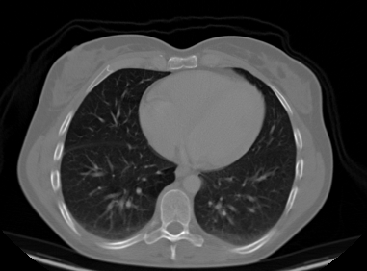
Large Cell Carcinoma
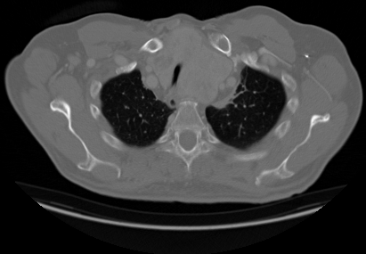
Squamous Cell Carcinoma

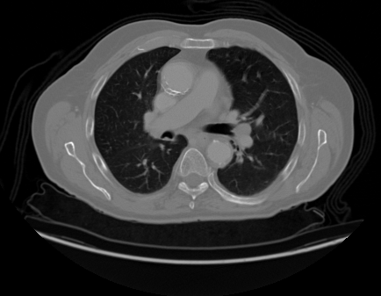

Normal

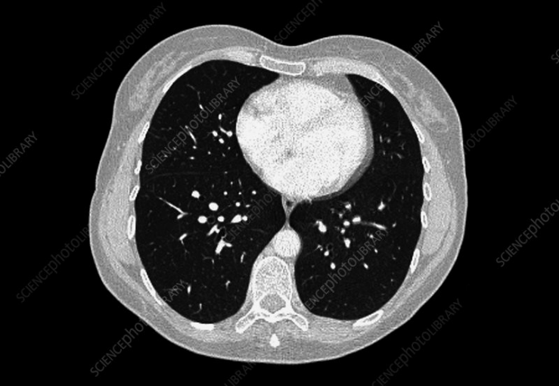

4. Methodology

4.1 Preprocessing and Augmentation
All images were resized to 224x224 pixels and pixel values were scaled to the range [0, 1] by dividing by 255. To help the model generalize better on the small dataset, the following augmentations were applied to training images only:

- Horizontal and vertical flipping
- Random rotation up to 20 degrees
- Zoom range of 0.2
- Brightness adjustment between 0.8 and 1.2
No augmentation was applied to validation or test data.

4.2 Model 1 — MiniConvNet (From Scratch)
MiniConvNet is our custom CNN built from scratch, following the paper's proposed architecture. It uses four convolutional blocks, each with a Conv2D layer, Batch Normalization, and Max Pooling. The filter count doubles in each block, starting from 16.

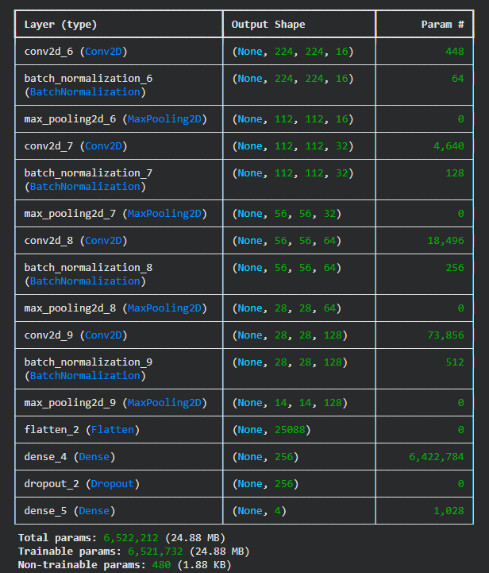

Architecture:
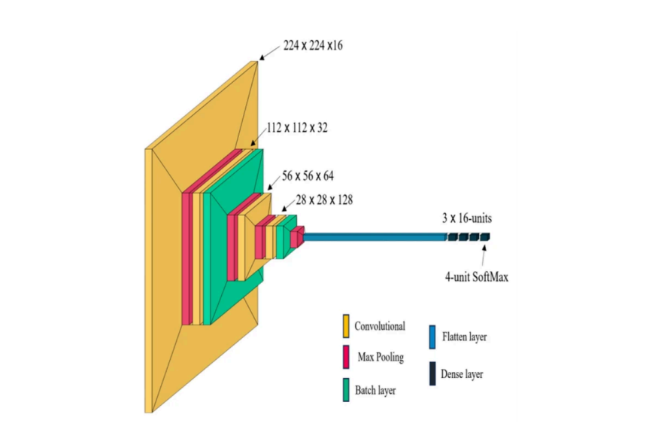
4.3 Model 2 — Transfer Learning Using MobileNetV2
The second approach used transfer learning with the pretrained MobileNetV2 architecture.
The second model uses MobileNetV2 pretrained on ImageNet.
The entire MobileNetV2 base was frozen. Only the custom classification head (GlobalAvgPool → Dense(128) → Dropout(0.5) → Dense(4, Softmax)) was trained for 10 epochs with a learning rate of 0.0001. This lets the head learn before any pretrained weights are touched.

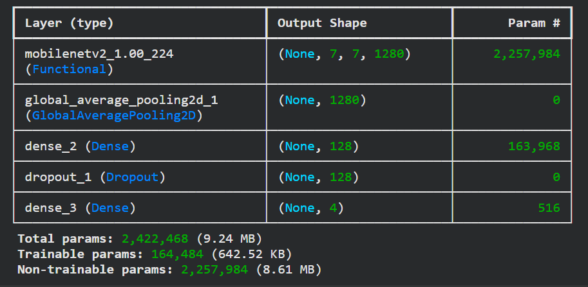

5. Experimental Setup

Setting | Value
Platform | Google Colab
Runtime | CPU only
Python | 3.10
TensorFlow | 2.15
Batch Size (MiniConvNet) | 16
Batch Size (MobileNetV2) | 32
Optimizer | Adam
Loss Function | Categorical Cross-Entropy
Max Epochs | 30 (MiniConvNet), 10 per phase (MobileNetV2)
Class Weights | Balanced (applied to all models)

6. Results
The performance of both implemented models was evaluated using different quality measures.
The following evaluation metrics were used:
- Accuracy
- Loss
- Precision
- Recall
- F1-score
- Confusion Matrix

6.1 CNN Trained from Scratch
Test Accuracy and Test Loss
Test Accuracy: 0.4413
Test Loss: 1.4055

Accuracy and Loss Curves
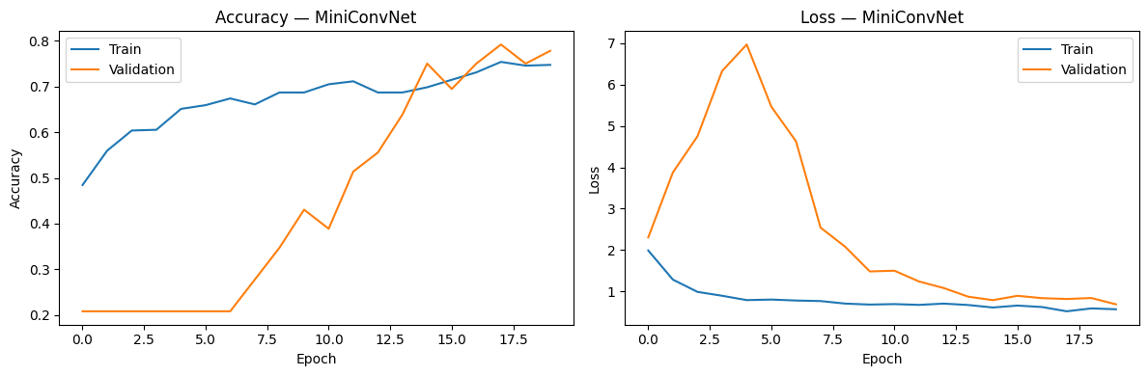
Classification Report
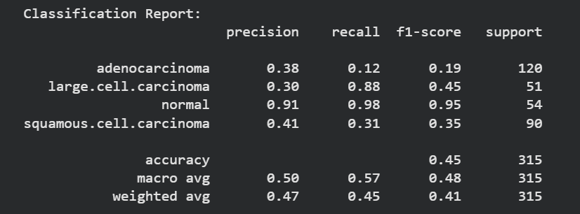
Confusion Matrix
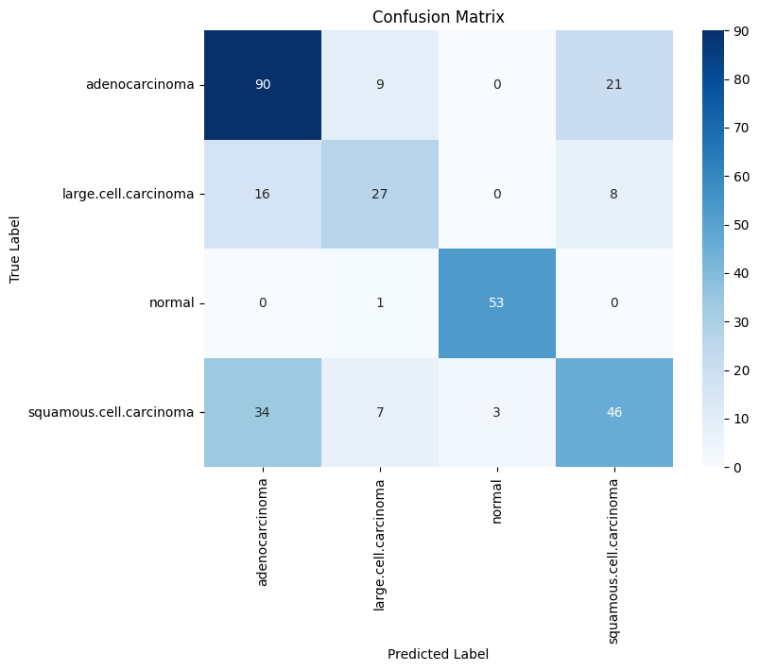
6.2 Transfer Learning Model
Test Accuracy and Test Loss
10/10 ━━━━━━━━━━━━━━━━━━━━ 17s 2s/step - accuracy: 0.6857 - loss: 0.8013
Test Accuracy: 0.6857143044471741
Test Loss: 0.8013045191764832
Accuracy and Loss Curves
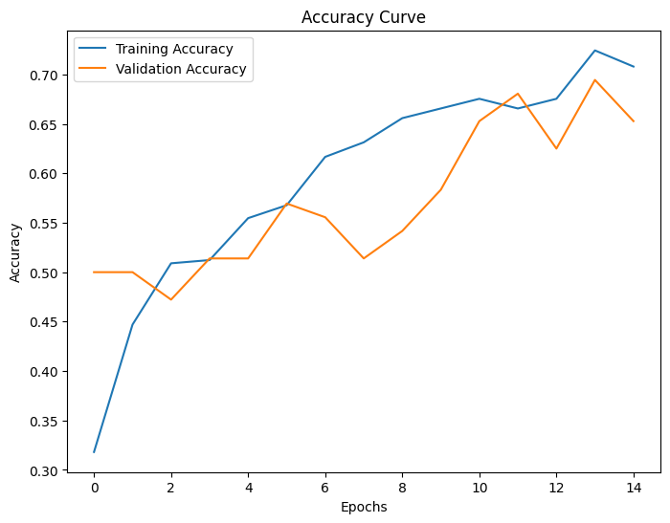
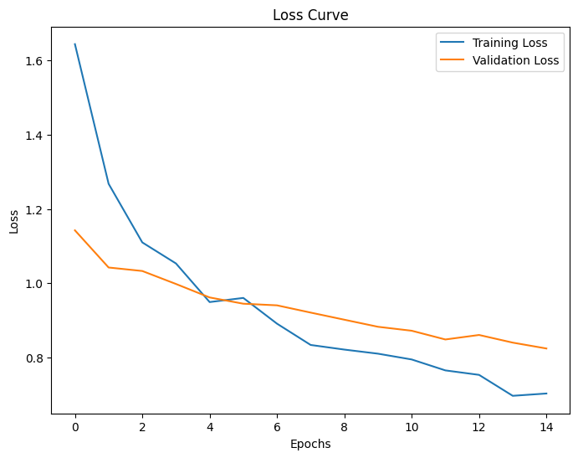
Classification Report:
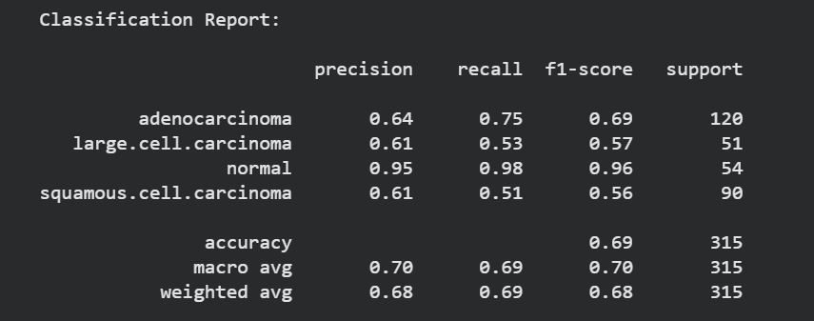

Confusion Matrix:
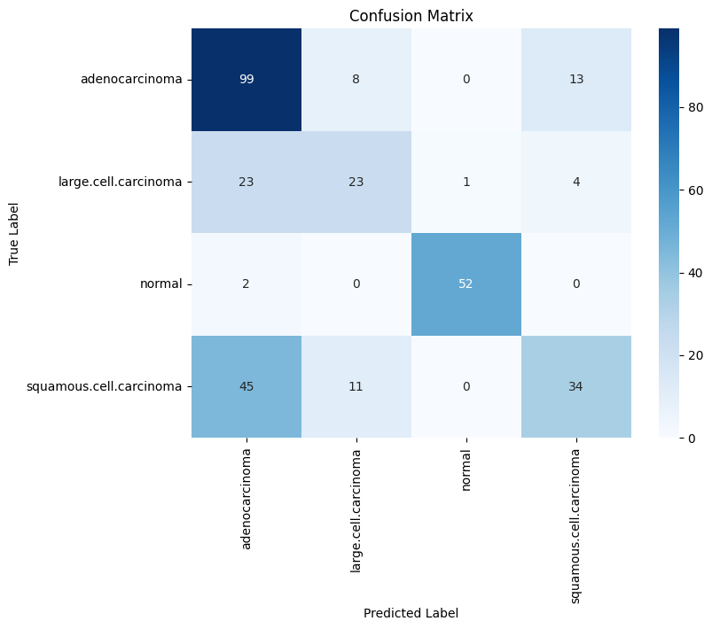

6.3 Paper Results
Author’s Model Results
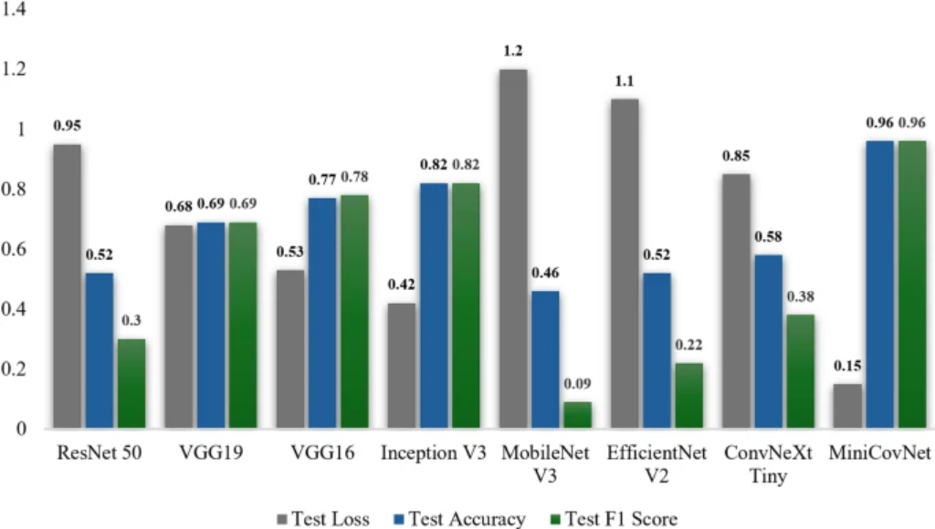

7. Comparison with Paper
The performance of the implemented models was compared with the results presented in the selected research paper.
Model | Accuracy | Remarks
CNN from Scratch | 44% | Lower performance due to limited feature extraction
Transfer Learning (MobileNetV2) | 68% | Improved classification performance
MiniConvNet (Paper) | 96% | Highest reported performance

8. Conclusion
This project successfully implemented CNN-based approaches for multiclass lung cancer classification using CT scan images. Two different approaches were evaluated: a custom CNN trained from scratch and a transfer learning model using MobileNetV2.
The results demonstrated that transfer learning significantly improved classification performance compared to the CNN trained from scratch. The pretrained MobileNetV2 model was able to extract more effective image features and achieve better generalization on medical imaging data.

9. Future Work
Several improvements can be made in future work to enhance classification performance:
- Use larger medical imaging datasets
- Train models using GPU acceleration
- Apply advanced transfer learning architectures
- Implement attention mechanisms
- Perform hyperparameter optimization
- Deploy the system for real-time hospital applications
Future research can further improve automated lung cancer diagnosis systems and assist healthcare professionals in early disease detection.
References
[1] M.E.H. Chowdhury et al., “A lightweight CNN for enhanced non-small cell lung cancer classification using CT scan image,” Nature Scientific Reports, 2026.
[2] Chest CT-Scan Images Dataset, Kaggle. Available: https://www.kaggle.com/datasets/mohamedhanyyy/chest-ctscan-images

